|  |  |
| --- | --- |
| **Name : Aradhana Rai** | **Date :** |
| **Roll No : 18102A0039** | **Signature :** |
| **Class : SE CMPN - A** | **Grade :** |
| **Batch :** |  |
| **Experiment No: 4** |  |

**Title:** 3 Bit Up Counter

**Estimated time to complete this experiment:** 2 hours

**Objective:**

1.Understanding behaviour of 3 Bit Up counter from module designed by the student as part of the experiment .

2.Understanding the concept of counters and their predefined sequence of states on application of clock pulses.

3.The 3 Bit up counter counts up , under the command of a control unit.

**Books/ Journals/ Websites referred:**

Books:

1.Digital Logic and Computer Design - M. Morris Mano. Pearson Education - Prentice Hall.

2.Digital Principles Foundation of Circuit Design and Application - Arun Kumar Singh. New Age Publishers.

3.The Art of Electronics - Paul Horowitz and Winfield Hill (1989). Cambridge University Press

4.Modern Dictionary of Electronics - Rudolf F. Graf (1999). Newnes

Web Sites:

* https://en.wikipedia.org/wiki/Counter_(digital)
* [NPTEL (e-learning courses from IITs and IISC)](http://nptel.iitm.ac.in/courses.php?disciplineId=106)

**Requirements:** Virtual simulator.

* **Components :-**
* 3 D Flip-Flops.
* 2 EX-OR gates and an and gate
* Wires to connect
* LED display to obtain the output

**Circuit Diagram:** 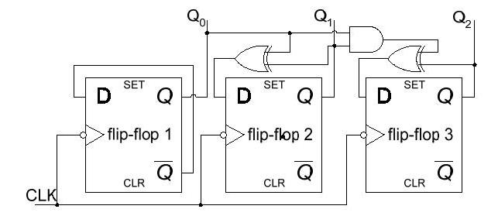

**Procedure:**

1. Start the simulator as directed.
2. To design the circuit we need 3 D Flip-Flops, 2 EX-OR gates, 1 Digital display( for checking output sum), 3 Bit displays(to see the output from each of the Flip-Flops), a clock input, wires.
3. The pin configuration of a component is shown whenever the mouse is hovered on any canned component of the palette. Pin numbering starts from 1 and from the bottom left corner(indicating with the circle) and increases anticlockwise.
4. For D Flip-Flop input is in pin-8 for clock input, preset and clear are set to 1, input from EX-OR gate is given to pin 5 of the flip-flop.
5. Click on the D flip-flop component with preset and clear (in the sequential circuits drawer in the pallet) and then click on the position of the editor window where you want to add the component(no drag and drop, simple click will serve the purpose), likewise add 2 more flip-flops(from the sequential circuits drawer in the pallet), 2 EX-OR gates and 1 and gate(from Logic Gates drawer in the pallete), 1 digital display and 3 bit Displays, 1 clock input(from Display and Input drawer of the pallet, if it is not seen scroll down in the drawer).
6. To connect any two components select the Connection menu of Palette, and then click on the Source terminal and click on the target terminal. According to the circuit diagram connect all the components. Start the clock input using the input provided in the top palette the output from each flip-flop is taken into a bit display which is then given to a digital display which displays the binary number

**Conclusion:**  The 3 bit up counter is used to count upto the number. However if we were required to implement a 12 bit up counter this would lead in an exponential increase in the parts required and the power required to drive it also, which would increase complexity and cost.

**Real Life Application:**

1. Multiplexing.
2. Digital Clocks.
3. Flashing light indicators.

**Post Lab Questions:**

Q. What is the reason that synchronous counters eliminate the delay problems encountered with asynchronous counter?

Q. What is the difference between serial and parallel transfer?

Q. How many flip-flops are required to make a MOD-32 binary counter?

Q. What is the number of flip-flops needed to design a MOD-19 counter?